Microsoft Team Assignment Creation Instructions

Copy and paste the texts here for the **First** and  **Retake Opportunity** respectively, make sure to match the settings of the screenshot

First Opportunity FAI1.P3-01 Project 1C ADS&AI 2022-23

There is no late hand in allowed after the deadline [Due Date : 7th April, 2023], kindly make sure all the required documents for assessment are added to your assignment accordingly.

The project described in this document is intended to offer you the opportunity to produce evidence of your progress in meeting this block’s Intended Learning Outcomes (ILOs).

Refer to the Assessment Sheet that has been shared with you to see how each student will be assessed in this block. The assessment sheet describes the Competencies that are addressed in this block, the Intended Learning Outcomes and the assessment rubric by which the grade is calculated. Each Assessment Indicator in the rubric is weighted to calculate a provisional grade which then can be adjusted by the assessors to derive a student’s final grade for the block.

After the deadline, your teaching team will weigh the evidence you provide (from GitHub repository/ Teams assignment) against each ILO, and a grade will be generated. Any adjustments made to that grade will be clearly outlined by the teaching team with supporting arguments.

Assessment is individual, and is based entirely on your own individual learning progress and contributions to the project - to this end, it is vital that you maintain your Work Log and Learning Log to provide sufficient evidence of your learning and project contributions. Along with the mandatory documents (Learning Log, Worklog and student self-assessment) all filled in, you can optionally upload other documents addressing your learning progress for this assessment.

In order for your professional competencies ILO’s to be graded your attendance during the Datalab sessions is a mandatory prerequisite. Attendance means on campus in the specified classroom; by default from 9:00 to 17:00, unless otherwise agreed upon by the teaching staff: e.g. online attendance because of corona, excused from attending because of personal circumstances by staff. Failing to attend more than 2 Datalab sessions without a valid reasons automatically means you failed the professional competencies ILO’s and need to retake these; alternatively you can object via the board of examiners to your automatic grading suspension.

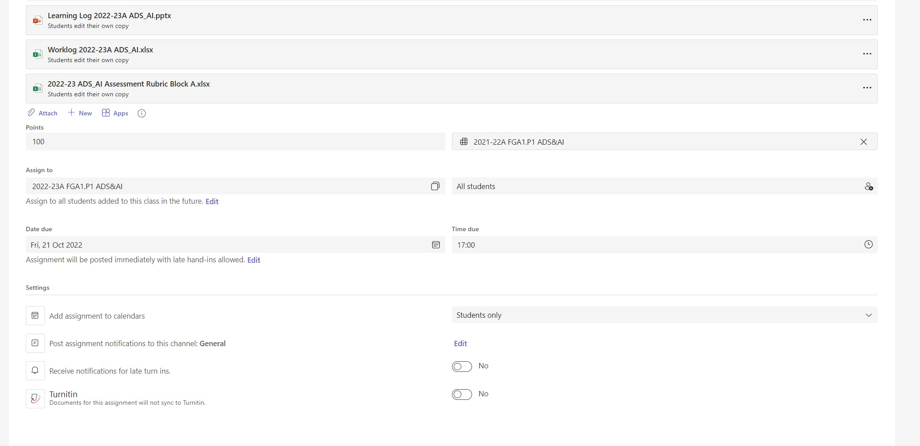

Retake Opportunity FAI1.P3-01 Project 1C ADS&AI 2022-23 [Due Date : 30th June 2023 - Friday Week 8 Block D]

Kindly read the Retake section in the Project Brief for more details on retake process and sign up process for a retake opportunity. You should hand-in this retake assignment for assessment before the deadline of the block. You can take this one time retake opportunity any block before the end of year, just **make sure you hand in the assignment before the block end deadline**for the assessment to happen in that block. eg: if you want to take block A retake, you should hand in this assessment before block B, block C or Block D deadline for it to be assessed in block B, block C or Block D respectively.

The project described in this document is intended to offer you the opportunity to produce evidence of your progress in meeting this block’s Intended Learning Outcomes (ILOs).

Refer to the Assessment Sheet that has been shared with you to see how each student will be assessed in this block. The assessment sheet describes the Competencies that are addressed in this block, the Intended Learning Outcomes and the assessment rubric by which the grade is calculated. Each Assessment Indicator in the rubric is weighted to calculate a provisional grade which then can be adjusted by the assessors to derive a student’s final grade for the block.

After the deadline, your teaching team will weigh the evidence you provide (from GitHub repository/ Teams assignment) against each ILO, and a grade will be generated. Any adjustments made to that grade will be clearly outlined by the teaching team with supporting arguments.

Assessment is individual, and is based entirely on your own individual learning progress and contributions to the project - to this end, it is vital that you maintain your Work Log and Learning Log to provide sufficient evidence of your learning and project contributions. Along with the mandatory documents (Learning Log, Worklog and student self-assessment) all filled in, you can optionally upload other documents addressing your learning progress for this assessment.

In order for your professional competencies ILO’s to be graded your attendance during the Datalab sessions is a mandatory prerequisite. Attendance means on campus in the specified classroom; by default from 9:00 to 17:00, unless otherwise agreed upon by the teaching staff: e.g. online attendance because of corona, excused from attending because of personal circumstances by staff. Failing to attend more than 2 Datalab sessions without a valid reasons automatically means you failed the professional competencies ILO’s and need to retake these; alternatively you can object via the board of examiners to your automatic grading suspension.

